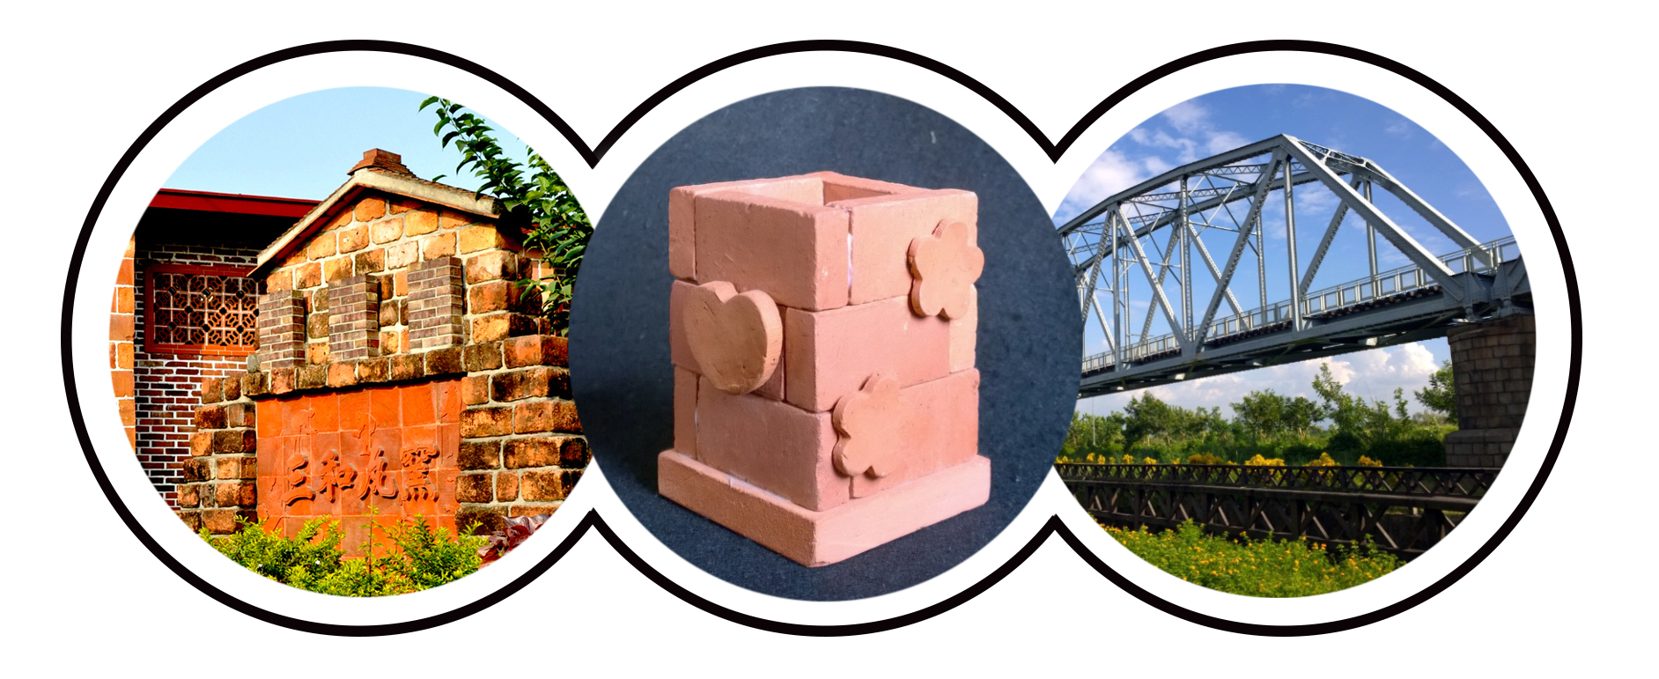
Jhuliao community is located in the southeast side of Dashu Village. The Kaohsiung-Pingtung old railway bridge located in this area is designated as a second level national historical site.
The abundant water and fine-grained soil present in this region are excellent for the manufacture of superior brick and tile building materials. There was a time when the kiln industry in Dashu district flourished extremely. But due to changing times, now, only the three “turtle” kilns of the San-he tile factory exist to contend against the new culture. Today, together with the host families, we will walk into Jhuliao community and take a look at the special panoramic view made by the historic old railway bridge set against green man-made wetlands. We will also learn the traditional kiln firing methods and tile manufacturing culture. Then, you can have some time to try to make your own personalized red brick pen container yourself.
高雄市大樹區竹寮社區
Jhuliao Community

- Location: Kaohsiung City Dashu District Jhuliao Community (高雄市大樹區竹寮社區)
- Date: November 21th, 2015
- Sponsor: Ministry of Education
- Organizer: Taiwan Hostfamily Program
- Participant:
(1) Host families
(2) International students currently attending a university/institution in Taiwan
*Free for all international students and host families
- Meeting point: Kaohsiung Railway Station (高雄火車站)
- Register: Please register online http://www.hostfamily.org.tw/en/news/85-8025
- Deadline: November 12th, 2015
- Contact Information:
Taiwan Hostfamily Program (Southern Taiwan University of Science and Technology)
Rita Cheng
Tel: 06-2533131 #1603
E-mail: hostfamily@mail.stust.edu.tw

- Notes:
Time | Content of Activity
10:20 | Gathering at Kaohsiung Railway Station
11:00-11:40 | Leave for Jhuliao Community
11:50-12:00 | First meet with your host family
12:00-13:00 | Community-style lunch with your host family
13:00-13:15 | Brief introduction of Jhuliao Community
13:20-15:20 | Community guided tours; learn the traditional kiln firing methods and tile manufacturing culture. Then make your own personalized red brick pen container with your host family.
15:30-16:30 | Happy time with host families and international students and write down your precious memory.
16:30-17:10 | Leave for Kaohsiung Railway Station
(1) Please bring your water bottle, rain gear and sun care products.
(2) Remember to wear comfortable, casual clothes and shoes.

